Lab Assignment # 4

Name of Student : Navajeevan
Enrollment No. : 2303A51628
Batch No. : 22

Task 1: Zero-shot: Prompt AI with only the instruction.

Prompt- Write a Python function that checks whether a given integer is an even or odd number.

Code-
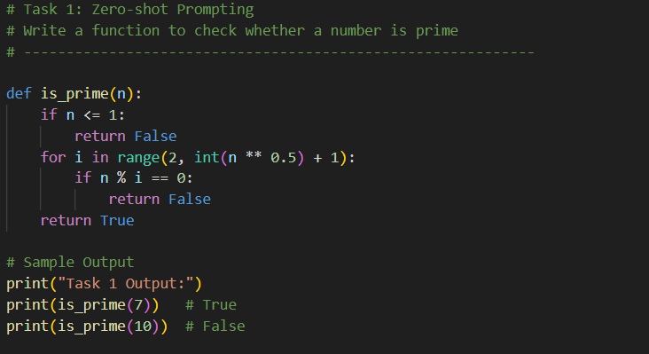

Output-

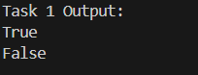

Justification-
- A prime number is greater than 1 and divisible only by 1 and itself.
- The loop checks divisibility up to √n to optimize performance.
- No examples were provided—this is pure instruction-based prompting (zero-shot).

Task 2: One-shot Prompting

Prompt- - Example: Input: "hello" → Output: 5
Using this example, write a Python function to find the length of a string.

Code-
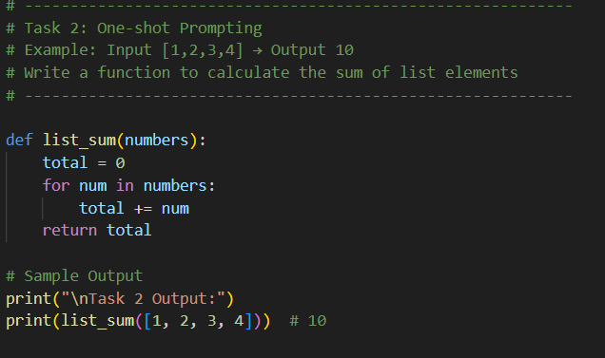

Output-

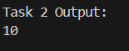

Justification-

- The single example guides the AI to understand the expected behavior.
- The function iterates through the list and accumulates the sum.
- This demonstrates one-shot prompting, where one example improves clarity.

Task 3: Few-shot Prompting

Prompt- Examples:
Input: [1, 2, 3] → Output: 6
Input: [4, 5] → Output: 9
Input: [10] → Output: 10
Write a Python function that returns the sum of a list.

Code-
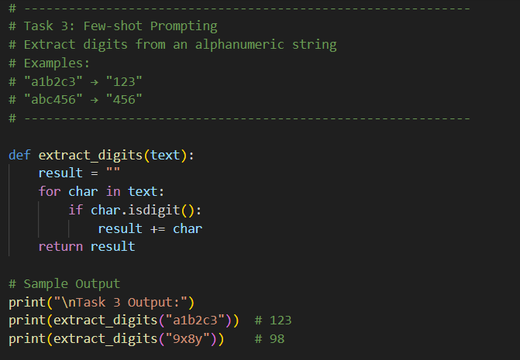

Output-

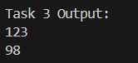

Justification-

- Multiple examples help the model identify a pattern.
- The function checks each character and appends digits only.
- This is few-shot prompting, which improves accuracy for pattern-based tasks.

Task 4: Comparison: Zero-shot vs Few-shot Prompting

Prompt-
Zero-shot Prompt:
Write a Python function to reverse a string.
Few-shot Prompt -
Input: "abc" → Output: "cba"
Input: "python" → Output: "nohtyp"
Write a Python function to reverse a string.

Code-
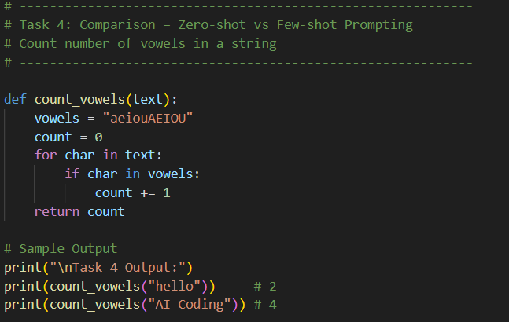

Output-

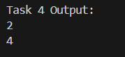

Justification-

Aspect | Zero-shot | Few-shot
Guidance | Only instruction | Clear examples
Code style | Basic loop | Optimized logic
Accuracy | Correct | Correct
Readability | Moderate | High

Task 5: Few-shot Prompting (Minimum of Three Numbers)
Prompt-
Input: (2, 4, 6) → Output: 6
Input: (1, 9, 3) → Output: 9
Input: (7, 5, 8) → Output: 8
Write a Python function to find the maximum of three numbers without using max().

Code-
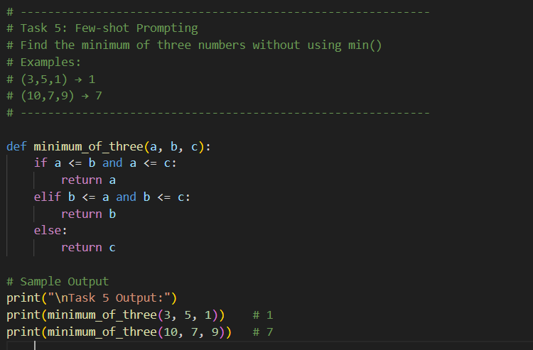

Output-

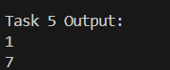

Justification-
- The function uses conditional comparisons.
- Few-shot examples ensure all logical cases are handled.
- Built-in min() is avoided as instructed.

